**Testing Exercises**

The first part of the exercise consists of creating an automated test suite using the following base technologies (Python and Selenium [any version and IDE]) or the language that you domain try to use a creative solution and the best practices.

In the section “Automated Testing” you can find series of scenarios to be automated, in each point you have the respective link to the page under test.

In the second part of this exercise, test evidence is needed to be created, for example, test cases, try to use a creative solution and best practices. You can propose your own format that you consider according to the type of test that you have chosen. In the section “Manual Testing” you can find a series of scenarios that will have to be done as requested in each of the points. Each of them has its respective link to the page to be tested.

**Points evaluate:**

* Good practices
* Technical knowledge
* Investigation
* Documentation

**Deliveries:**

* Source code or link to repository (Gitlab, GitHub, etc.)
* Document about how to install all the dependencies necessaries and the steps to run all the automated tests and the test cases created (Word, PDF).

**Due Date:** March 7, 2022, until 11:59 PM.

**Note:** Please send the files requested in the deliveries section to the following emails:

* jonathan.sanchez@sonorasoft.com
* manuel.montoya@sonorasoft.com
* hiram.davis@sonorasoft.com

Finally, if you have any questions do not hesitate to contact us, Good Luck.

**Automated Testing**

* [Dynamic Content](https://ss-testing-automated-exercise.herokuapp.com/dynamic_content)
  + Go to Dynamic Content page and refresh it until the 3 images and texts are not repeated between them.

e.g.

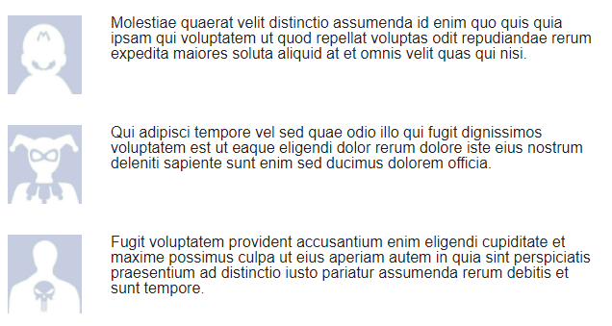

* [Login](https://ss-testing-automated-exercise.herokuapp.com/login)
  + Login with valid credentials
  + Validate the authentication was successful.
  + Login with not valid credentials
  + Validate the authentication was unsuccessful.

**Manual Testing**

Create test cases for each point, you can create the number of tests you think are necessary to cover the functionality of the page.

* [Upload File](https://ss-testing-automated-exercise.herokuapp.com/upload)
* [Geolocation](https://ss-testing-automated-exercise.herokuapp.com/geolocation)
* [Login](https://ss-testing-automated-exercise.herokuapp.com/login)